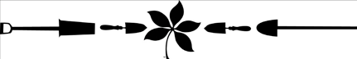

OSUE Greene County Master Gardener Volunteer
2021 Best in Season Award Form
Deadline: on or before October 1, 2021

Nominee description:

Category (chose from one from list below):
  - Largest vegetable
  - Most unique flower – color, shape, or size
  - Produce with unusual appearance
  - Most interesting insect

Project/Location of entry:

Nominator name:

You must include a picture of your entry to be considered for this award. The entry does not have to have been found at a MGV project or from your own yard. As long as it was in Greene County and you are the photographer. *You cannot enter an item from a fair, contest, or commercial establishment (i.e. nursery). One category per entry form no limit on entries per MGV. An award will be given to one entry in each category. Then a “Best in Season” award will be presented.

Please submit the form and photo through email to Jane Worth at: jmw1526@gmail.com

Category awards to be seed packets (vegetable seed, flower seed, unusual seed, and magnifier) *Some order as categories listed. Frame and display picture in a common area till next year winners are announced. Overall winner to receive a gift card (committee to decide from where) and a Best in Season ribbon displayed on picture.

